*Britl!* User Manual

*Britl!* Is a basic marketplace app intended for use in educational institutions. It allows:

* Creation/deletion of Users
* Login/Logout
* Post items for sale
* Delete Items
* View items for sale
* View items posted by your user

For now, all other functionality has to be requested to the admin as development allows for more features.

1. **Creation/deletion of Users**

To create user, Click on the “Login” link:

Then, click on “Sign Up”

Fill out the form with your Name, Last Name, Email address and password, and choose a an image, and click on the “Sign Up” button at the bottom of the form

You will see a “User Created successfully” Message

1. **Login existing user**

To Login, simply click on the “Login” link

Enter your email address and password and click on “Login”

1. **Logout**

Once you’re logged in, the “Logout” button will be made visible. Click on it to be logged out

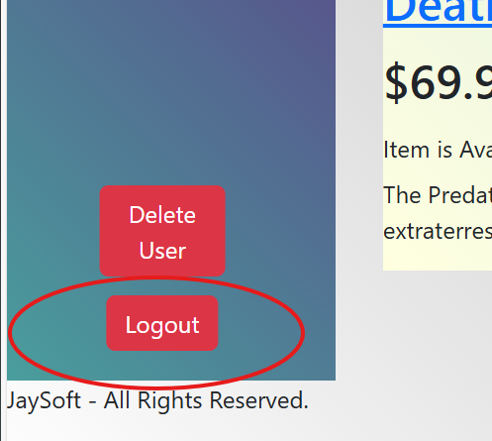

1. Delete User

Once You’re logged in, the “Delete User” button will be made visible. Click on it to delete the currently logged in user.

1. **Post items for sale**

To post an item for sale, it’s required that you’re an existing user and that you’re logged in. Once these conditions have been met, Click on the “Post an Item” link

Fill out the form with the item’s information (Item Name, Description, Price and image) and click on Submit item. Please make sure to include contact information in the description to allow potential buyers to contact you for transactional purposes.

1. **Delete Items**

To delete an item, you need to be a user, and be logged in. Select an item and click on it’s name Link to access it.

You will se an extended display of the item. Click on “Delete Item” to delete it.

1. **View items for sale**

To view items for sale, If you’re not logged in you will see a general list of all items on the homepage.

1. View items posted by your user

To view your items, simply login and the list will change from the general view, to only your items. Logout to go back to General view.

